Student Management API Operations
- POST /students – Create Student
Performed the POST operation for student ID 101 and successfully created the student.
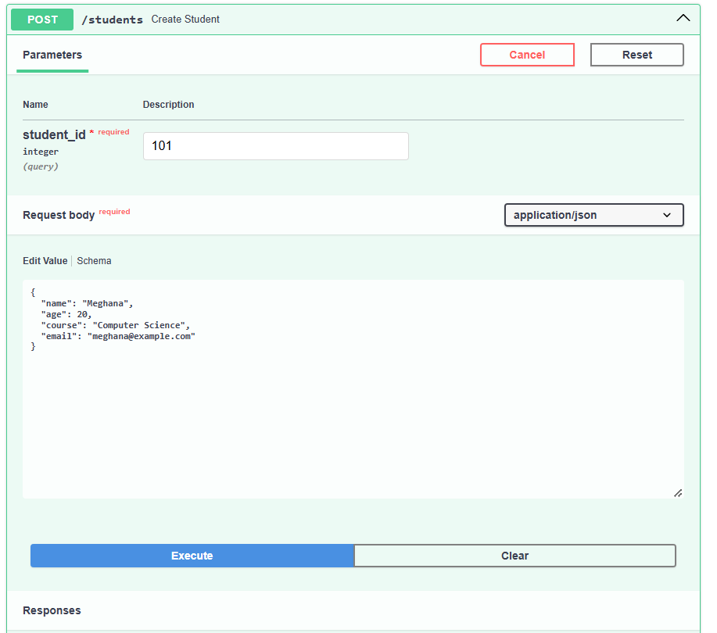
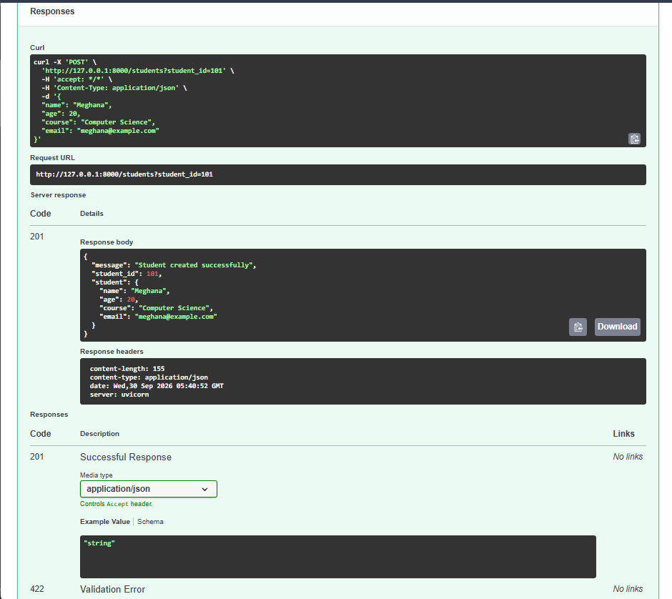

- GET /students – Get Students
Performed the GET operation to retrieve the student records and displayed the details of student ID 101.
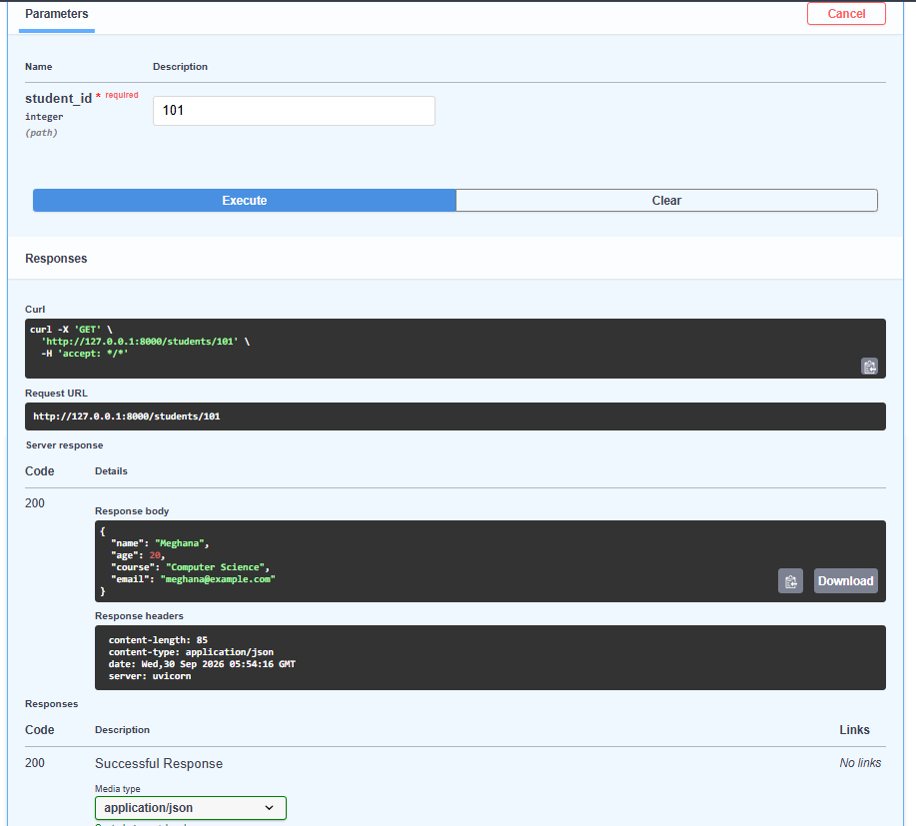
- PUT /students/{student_id} – Update Student
Performed the PUT operation for student ID 101 and successfully updated all the student's details.
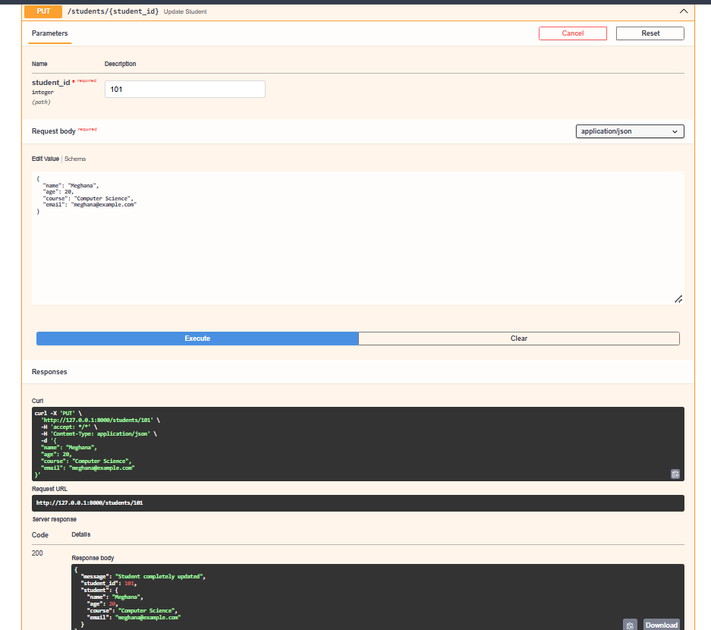
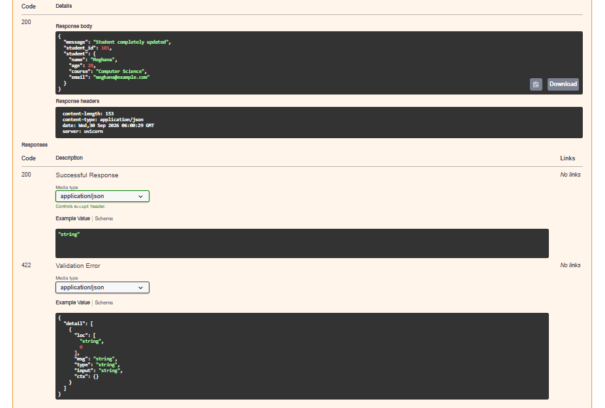
- PATCH /students/{student_id} – Partial Update Student
Performed the PATCH operation for student ID 101 and successfully updated the course to Data Science
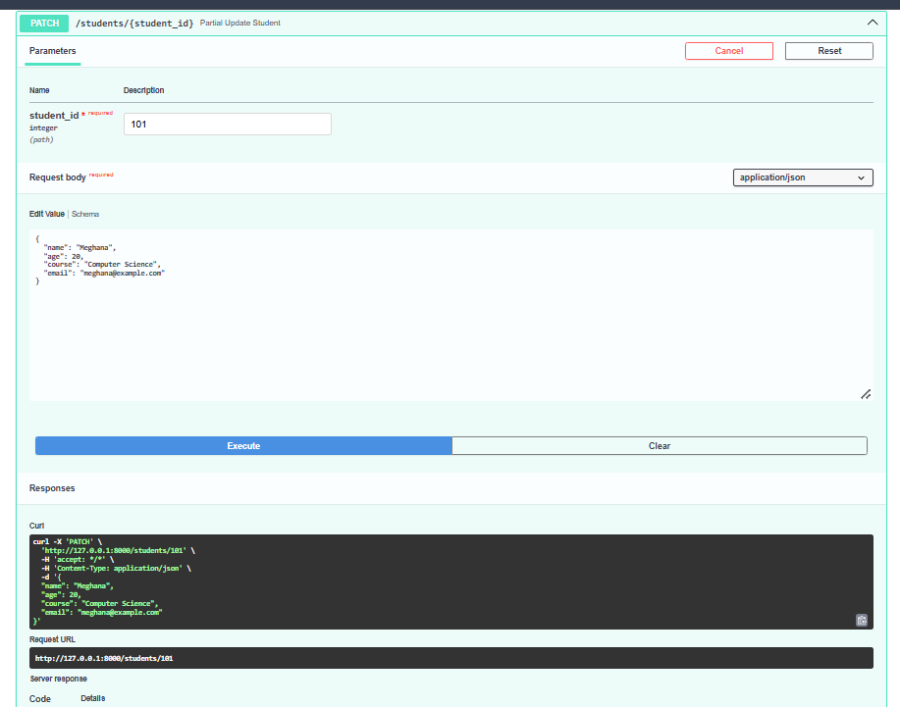
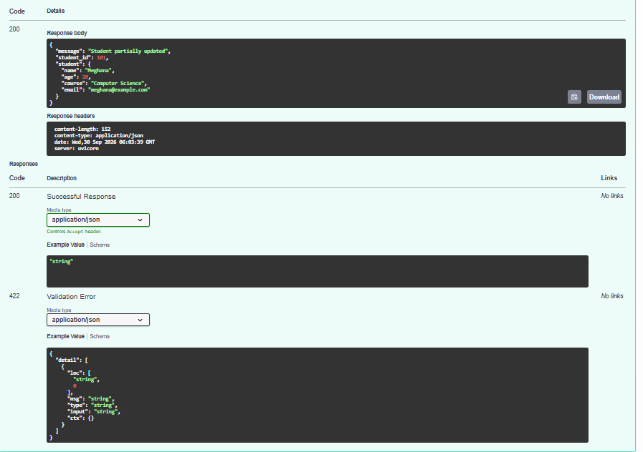
- DELETE /students/{student_id} – Delete Student
Performed the DELETE operation for student ID 101 and successfully deleted the student record.
